**Prekindergarten Curriculum**

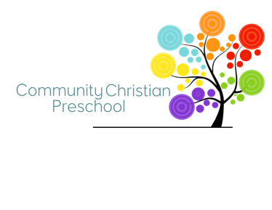Prekindergarten classes provide children with a classroom environment and curriculum intended to build foundational skills necessary to successfully enter kindergarten. Our Prekindergarten classes incorporate the following skills and subject matter throughout the course of the school year. Our curriculum reflects criteria detailed in Ohio’s Early Learning and Development Standards. Pacing of curriculum is communicated monthly/weekly to parents by your child’s classroom teacher.

# Language/Literacy

* Recognizing and Writing Name
* Identifying Uppercase Letters
* Identifying Lowercase Letters
* Writing Upper and Lowercase Letters
* Sequencing Letters
* Beginning Sound Awareness
* Vocabulary
* Read Aloud Comprehension
* Book Awareness
* Print Awareness
* Rhyming
* Opposites

**Social Studies**

* People, Communities, and Environment

# Math

* Counting and Sets o Counting 1-20, 1-100 (end of year)
  + One to one correspondence o Skip counting by 10s o Forming Sets o Comparing Sets (fewer/more)
  + Combining and separating sets
* Numbers
  + Number Identification 1-30

(Naming numbers) o Number Formation (tracing and writing)

* + Matching sets to numbers

(quantities)

* + Sequencing/Ordering o Comparing Numbers
  + Identifying number names
* Geometry
  + Basic shapes (2D) o Shape attributes o Drawing shapes o Shapes in environment o Positional words o Complex shapes (3D) o Working with shapes
* Patterning o Copying and extending patterns
  + Making patterns
* Measurement
  + Exploring length
  + Exploring weight
* Data
  + Sorting collections o Graphing
* Colors o Identifying colors and color

words

* + Mixing and Matching

# Science

* Force and Motion
* States of Matter
* Living and Nonliving Things
* Weather, Temperature, and Seasons
* Size and Shape
* Sink or Float
* Magnets
* My Body
* Change and Growth
* Make Observations and Predictions
* Rocks and Soil
* Caring for the Earth

# School Readiness

* Building Listening Skills
* Following Directions
* Performing Steps in a Sequence • Working Within a Group
* Communicating within a Group
* Self-Awareness and Regulation
* Fine motor skills o Tracing, writing, drawing o Glue (glue stick and liquid glue) o Using Scissors
* Gross Motor skills
* Physical Health and Development
* Building Learning Stamina
* Artistic Expression (crafts and music)
* Dramatic Play
* Pretend Play

|  |
| --- |
| *See bible curriculum for big ideas and stories explored throughout the school year as well as monthly bible verses. |